
SOUTH EAST EDUCATION DIVISION EXAMINATIONS

2026 MALAWI SCHOOL CERTIFICATE OF EDUCATION MOCK EXAMINATION

CHEMISTRY
Subject Number: M038/I
Tuesday, 24 March Time Allowed: 2 hours
8:00 - 10:00 am
PAPER I
(100 marks)
Theory
Instructions:

- This paper contains 12 printed pages. Please check.
Question Number | Tick if answered | Do not write in these columns
1
2
3
4
5
6
7
8
9
10
11
12
13
- Fill in your Examination number at the top of each page.
- This paper has two sections, A and B. In Section A there are ten short questions while in section B there are three restricted essay questions.
- Answer all the thirteen questions in the spaces provided.
- Use of electronic calculators is allowed
- The maximum number of marks for each answer is indicated against each question.
- In the table provided on this page, tick against the number of the question you have answered.

©2026 SEED MOCK Turn over

SECTION A (70 marks)

1. a. Explain why bond breaking is endothermic and bond making is exothermic.
______________________________________________________________________________
______________________________________________________________________________
______________________________________________________________________________
(2 marks)
b. State any two importance of endothermic reactions in everyday life.
______________________________________________________________________________
______________________________________________________________________________
(2 marks)
2. a. Define a polymer.
______________________________________________________________________________
______________________________________________________________________________
(1 mark)
b. Figure 1 shows polymerisation process of one of the monomers.
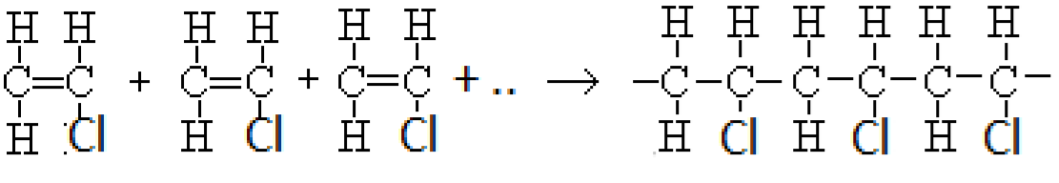
Figure 1
i. Name the type of polymerisation shown by the reaction above.
_____________________________________________________________________ (1 mark)
ii. Name the polymer formed in 2b. above.
_____________________________________________________________________ (1 mark)
iii. Describe how the polymer mentioned in 2b (ii) is formed.
______________________________________________________________________________
______________________________________________________________________________
______________________________________________________________________________
- marks)
Continued/…

3. a. Figure 2 shows allotropes of carbon labelled P and Q.
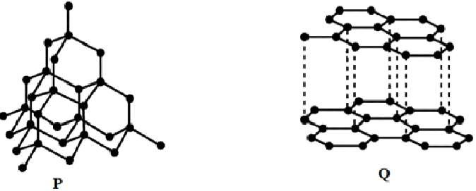
Figure 2
i, Identify the allotrope that conducts electricity.
____________________________________________________________________ (1 mark)
ii, Which allotrope is used to make surgery instruments?
____________________________________________________________________ (1 mark)
iii, Explain why the allotrope mentioned in 3 a (ii) is used to make surgery instruments.
_____________________________________________________________________________
(1mark)
- Explain why ionic compounds conduct electricity in molten state and not in solid state.
______________________________________________________________________________
______________________________________________________________________________
______________________________________________________________________________
______________________________________________________________________________
(2 marks) c. State any one use of Perspex.
______________________________________________________________________________ _____________________________________________________________________________
(1mark)
4. a. Define oxidation in terms of electron transfer.
_____________________________________________________________________________
(1 mark)
Continued/…

b. The electrode potential of copper and iron are as given below:
Fe²⁺ _{(aq)} + 2e⁻ Fe _{(s)} ; E⁰ = - 0.44V
Cu²⁺ _{(aq)} + 2e⁻ Cu _{(s)} ; E⁰ = +0.34V
Find the e.m.f of the cell obtained when copper and iron are combined.
_____________________________________________________________________________
_____________________________________________________________________________
_____________________________________________________________________________
_____________________________________________________________________________
(3 marks)
- State any one use of propanone.
________________________________________________________________ (1 mark)
- Define an alloy.
______________________________________________________________________________
______________________________________________________________________________
  - mark)
e, Which alloy is used to manufacture airplane parts?
______________________________________________________________________________
(1 mark)
5. Figure 3 is a diagram showing chromatography process of ink spots X and Y.

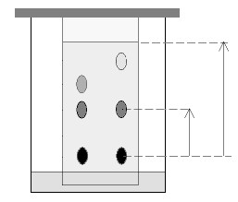
distance travelled by solvent

chromatograms R 10cm
P
M N distance travelled by component
ink spot X Y 4cm
solvent base line

Figure 3
Continued/…
a, Which two components are absorbed more strongly by the stationery phase?
______________________________________________________________________________
(2 marks)
b.i, Which component is most soluble in the solvent?
______________________________________________________________________________
(1 mark) ii, Give a reason for the answer in 2b.i. above.
______________________________________________________________________________
______________________________________________________________________________
(1 mark)
c. Calculate the relative flow value for component M.
______________________________________________________________________________
______________________________________________________________________________
______________________________________________________________________________
______________________________________________________________________________
______________________________________________________________________________
(3 marks)
6. Methane (CH₄) react completely with oxygen (O₂) to produce carbon dioxide and water.
a. Write a balanced chemical equation for the reaction.
______________________________________________________________________________
  - marks)
b. If 3.2g of methane reacted with oxygen, how much carbon dioxide was produced?
(RAM: C= 12, H = 1, O = 16).
______________________________________________________________________________
______________________________________________________________________________ ______________________________________________________________________________ ______________________________________________________________________________
______________________________________________________________________________
(3 marks)
Continued/…
c. Calculate the volume of oxygen required to burn 3.2g of methane completely at room
temperature and pressure? (Molar volume at r.t.p = 24dm³).
______________________________________________________________________________
______________________________________________________________________________
______________________________________________________________________________
______________________________________________________________________________
(4 marks)
7. a. Define water pollution.
______________________________________________________________________________
______________________________________________________________________________
    - mark)
b. State any two pollutants of water.
______________________________________________________________________________
______________________________________________________________________________
    - marks)
c, Mention any two health benefits of hard water?
______________________________________________________________________________
______________________________________________________________________________
(2 marks)
d, State any one advantage of “reduction at source” as one way of minimizing wastes.
______________________________________________________________________________
______________________________________________________________________________
(1 mark)
8. a. What is meant by “empirical formula of a compound”?
____________________________________________________________________________
____________________________________________________________________________
____________________________________________________________________________
(1 mark)

Continued/…
b. Work out the empirical formula of a compound that has the following percentage
composition by mass of elements: C = 40%, H=6.67%, and O = 53.33%.
(RAM C = 12, H = 1, O = 16)
______________________________________________________________________________ ______________________________________________________________________________ ______________________________________________________________________________
______________________________________________________________________________ ______________________________________________________________________________ ______________________________________________________________________________
______________________________________________________________________________ ______________________________________________________________________________ ______________________________________________________________________________
______________________________________________________________________________
(6 marks) c. State any two uses of phosphoric acid.
______________________________________________________________________________
______________________________________________________________________________
(2 marks)
9. a. Below are condensed formulae of some organic compounds.
- CH₃CH₂COCH(CH₃)CH₃
- CH₃CH₂CH(CH₃)CH₂COOH
- CH₃CH₂CH₂CHO
- CH₃CH₂CHOHCH₂CH₃
i. Name organic compounds A and B.
A: _____________________________________________________ (1 mark)
B: _____________________________________________________ (1 mark)
b. Draw the structural formula of a compound which is a conformer to organic compound C.

(1 mark)
Continued/…
- Which organic compound can react with compound B to produce an ester.
____________________________________________________________________ (1 mark)
- Which organic compound can give positive results with Tollens test.
______________________________________________________________________________
(1 mark)
- Write the products of the following chemical equation.
2C₂H₅OH(l) + 2Na(s) → _______________ + _________ (3 marks)

10. a. Figure 4 shows a graph of volume of gas collected against time for the reaction of
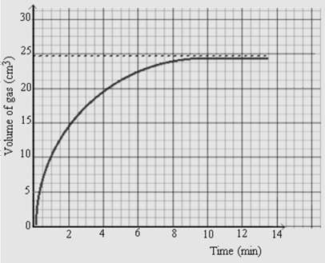
magnesium with hydrochloric acid at a certain concentration.

Figure 4. Graph for the reaction of magnesium and hydrochloric acid against time.
i. What was the maximum volume of the gas collected from the reaction?
______________________________________________________________________________
(1 mark) ii. After how many minutes did the reaction stop?
______________________________________________________________________________
(1 mark)

Continued/…
iii. Calculate the rate of reaction between 1 and 3 minutes?
______________________________________________________________________________ ______________________________________________________________________________
______________________________________________________________________________ ______________________________________________________________________________ ______________________________________________________________________________ ______________________________________________________________________________ ______________________________________________________________________________ ______________________________________________________________________________
______________________________________________________________________________
______________________________________________________________________________
______________________________________________________________________________
(5 marks)
c. Explain how burning of fuels causes global warming.
______________________________________________________________________________ ______________________________________________________________________________ ______________________________________________________________________________ ______________________________________________________________________________
______________________________________________________________________________
______________________________________________________________________________
(2 marks)

Continued/…

SECTION B (30 marks)
11.a. Describe how deforestation increases the concentration of carbon dioxide in the atmosphere.
______________________________________________________________________________ ______________________________________________________________________________
______________________________________________________________________________
______________________________________________________________________________ ______________________________________________________________________________ ______________________________________________________________________________ ______________________________________________________________________________
______________________________________________________________________________
______________________________________________________________________________ ______________________________________________________________________________ ______________________________________________________________________________
______________________________________________________________________________
(5 marks) b. Describe how nitrogen is isolated from air in the laboratory.
______________________________________________________________________________
______________________________________________________________________________
______________________________________________________________________________ ______________________________________________________________________________ ______________________________________________________________________________
______________________________________________________________________________ ______________________________________________________________________________ ______________________________________________________________________________ ______________________________________________________________________________ ______________________________________________________________________________
______________________________________________________________________________
______________________________________________________________________________
(5 marks)
Continued/…
12. With the aid of a well labelled diagram, describe how copper can be refined using electrolysis
process.

___________________________________________________________________________
___________________________________________________________________________
___________________________________________________________________________ ___________________________________________________________________________ ___________________________________________________________________________
___________________________________________________________________________ ___________________________________________________________________________ ___________________________________________________________________________
___________________________________________________________________________
___________________________________________________________________________ ______________________________________________________________________________ ______________________________________________________________________________ ___________________________________________________________________________ ___________________________________________________________________________
___________________________________________________________________________
___________________________________________________________________________ ___________________________________________________________________________
___________________________________________________________________________
(10 marks)
Continued/…
13. In a laboratory, labels fell off from the bottles containing an alkane, alkene, alkanol and
alkanoic acid. Describe an experiment that could be done to identify the contents of the bottle.
______________________________________________________________________________ ______________________________________________________________________________
______________________________________________________________________________
______________________________________________________________________________ ______________________________________________________________________________ ______________________________________________________________________________
______________________________________________________________________________ ______________________________________________________________________________ ______________________________________________________________________________
______________________________________________________________________________ ______________________________________________________________________________ ______________________________________________________________________________
______________________________________________________________________________ ______________________________________________________________________________ ______________________________________________________________________________
______________________________________________________________________________
______________________________________________________________________________ ______________________________________________________________________________ ______________________________________________________________________________ ______________________________________________________________________________ ______________________________________________________________________________ ______________________________________________________________________________ ______________________________________________________________________________ ______________________________________________________________________________
______________________________________________________________________________
(10 marks) END OF QUESTION PAPER
NB: This paper contains 12 printed pages.

